FACILITATOR’S GUIDE
Sex Worker Health & Harm Reduction 101

This guide is meant to accompany the Slide Deck for “Sex Worker Health & Harm Reduction 101,” developed by Reframe Health and Justice for NASTAD in the fall of 2022. This presentation is recommended for 90 minutes, depending on the size and format of the audience, to leave time for interactive elements.

Purpose: To offer an introduction on sex work and sex workers for a health-focused audience.

*Based on a 1:00 pm - 2:30 schedule, can be adjusted for any ninety-minute to two-hour time slot. Many of the slides have attached questions for audience participation which can be incorporated based on the number of attendees.

Materials:
- Slide Deck
- Handout and Resource Page
- For Virtual Trainings:
  - Create a Google Doc or Jamboard to share for audience participation
- In-Person Trainings:
  - Post-Its
  - Whiteboard or Large sheets of paper

Slide Image | Recommendations,  Additional Notes | Take-Aways
SLIDE 1: TITLE SLIDE
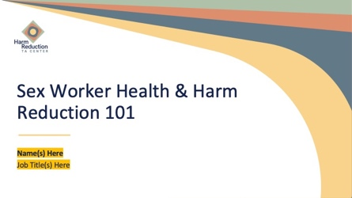

SLIDE 2: AGENDA
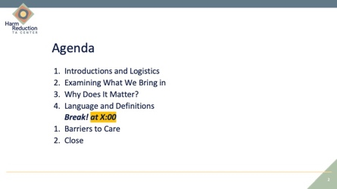
SLIDE 3: LOGISTICS AND INTRODUCTIONS
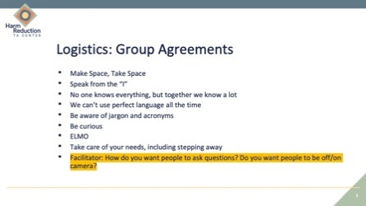 | “Logistics” is anything to review in preparation for the information.  For All Audiences:  - Include the collective agreements for conversations and notes about trigger and content warnings if necessary.  - Ask if anyone would like to add to these agreements or would like clarification.  - Depending on the size of the audience, decide whether only the facilitator is going to introduce themselves, or each audience member is going to introduce themselves. If the audience is too large for a go-around and you would still like audience introductions, ask people to introduce themselves to the two people on either side of them instead.  - ELMO stands for “enough, let’s move on”  For Virtual Audiences:  - Note if you would like them to remain on or off camera, to mute themselves, info about recordings and accessing any materials  For In-Person Audiences:  - Offer information about the space, including bathrooms and where people can go if they need to step away.
SLIDE 4: OBJECTIVES
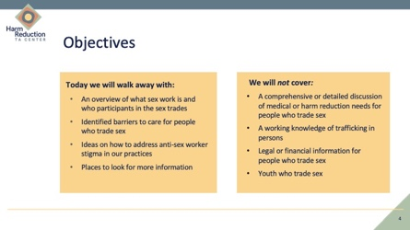 | - For topics not covered, direct people to the handout, which has links to more information
SLIDE 5: WHAT COMES TO MIND (EXERCISE)
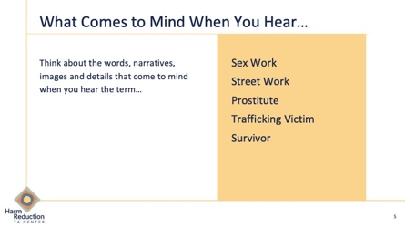  Sample Sheets for Virtual Trainings:  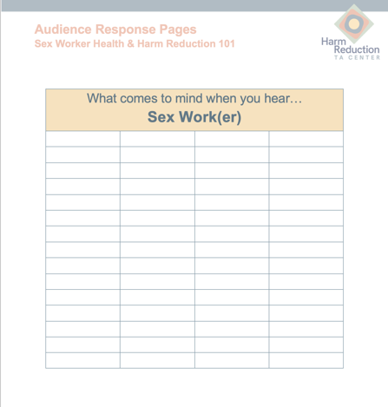  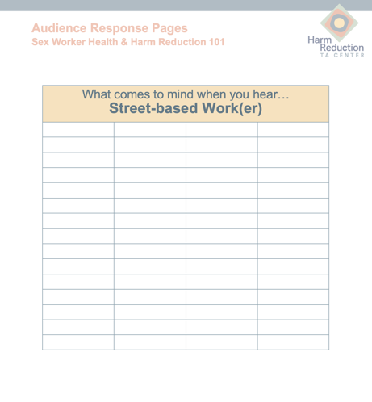 | - Let the audience know that this is a moment to reflect and that there are no right or wrong answers.  - Purpose is to identify our initial reactions to these terms and experiences. Beginning with self-reflection helps us identify our growing edges.  - For Virtual Training: Direct everyone to the virtual brainstorm boards. Each word has its own space on the document, either as pages on a google doc or sections of a Jam Board. As we go through each word, direct participants to scroll to the sheet with the corresponding word to respond. Responses are anonymous.  - Words will appear individually upon mouse click.  - Say each word aloud and ask people to reflect on what comes to mind and write the answer down in the corresponding location.  - After 10 seconds for reflection, ask people to share collectively and write down the words to form a collective definition.  - After all of the words have been read, review the collective brainstorm for each aloud and ask people to share their reactions to each definition.  For In-Person Trainings:  - Have large sheets of paper with each word written on the top to hang separately on the walls.  - Hand out post-it’s to participants and ask people to write down what comes to mind on a new post-it for each word.  - After all words are covered, ask people to put their post-it’s on the larger sheets with the corresponding word  - Review each large sheet at the end of the exercise and ask for reactions  For Virtual Trainings:  - Use a virtual document or program where you can type words into the document directly as you go over each word.  - After all the words have been covered, share your screen to review each virtual page of words  - Ask people their reactions | This slide is an exercise of reflection to identify our internal narratives and biases around the issue of sex work and people in the sex trades.  Tools Needed for In-Person Training: Large presentation paper, stacks of post-it notes.  Tools Needed for Virtual Training: Prepared virtual board either on Google Docs, Jamboard, or Menti.
SLIDE 6: WHERE DO WE GET THESE NARRATIVES?
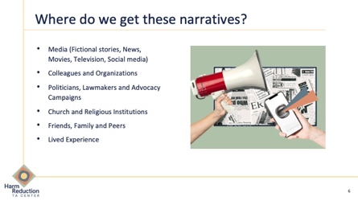 | - Ask audience to think about and share where some of these ideas have come from  - Review list on the slide | Without intentionally expanding our idea of the sex trade, we are internalizing ideas about the sex trade, often created by other people for purposes other than understanding or liberation.
SLIDE 7: SMALL GROUP DISCUSSION
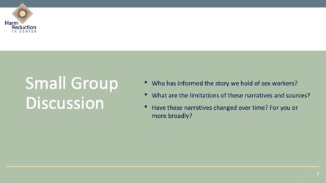 | - Ask audience to form groups of 3 to 4 or let them know that they will be placed in breakout rooms  - Give 5 to 7 minutes to each group to discuss the following questions:  - Where and who else has created this story of sex workers?  - What are the limitations of these narratives and sources?  - Have these narratives changed over time? For you or more broadly?  - Bring group back together and ask the whole group each question for a brief report back | - Where and who else has created this story of sex workers?  Take Away: Many different actors have had a stake in telling the story of sex work, often people who are not trading sex and affected by the ramifications of that story.  - What are the limitations of these narratives and sources?  Take Away: Stories may be limited by storytellers with no connection to the work or community, a single narrative, stories purposed to give a moral or criminal-legal narrative that is not in line with our values, or for sensationalism.  - Have these narratives changed over time? For you or more broadly?  Take Away: We are always learning and expanding, and growth means a constant process of adding nuance.
SLIDE 8: VIDEO
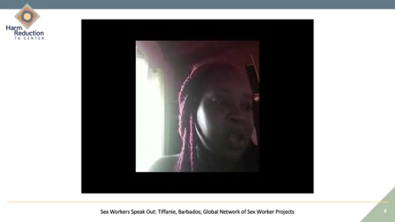 | Video is a sex worker advocate talking about the experience of sex workers in Barbados.  Video Length: 56 seconds  Video Note: When clicking to start the video, the “CC” button will make sure that English subtitles are on. If they are not automatically generated, click on the white box that says “CC” in black letters. | Main Points in the video:  - Sex workers experience discrimination, abuse, and lack of protection  - Law enforcement officers perpetrate violence against sex workers.  - Sex workers are human beings and deserve rights.  - Sex work is work.
SLIDE 9: WHY DOES IT MATTER?
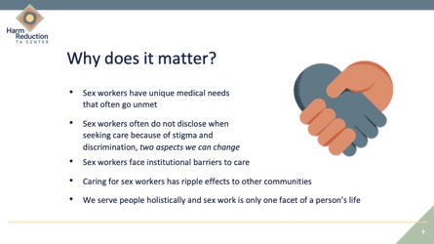 |  | There are significant impacts that can be made in care if we better serve people in the sex trades.
SLIDE 10: SECTION TITLE SLIDE; LANGUAGE AND DEFINITIONS
SLIDE 11: WHAT IS HARM REDUCTION?
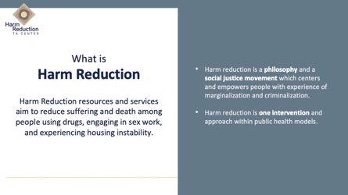 | - Review slide  - Ask for any additions to this definition | Harm reduction is a philosophy and a type of intervention.
SLIDE 12: WHAT IS SEX WORK?
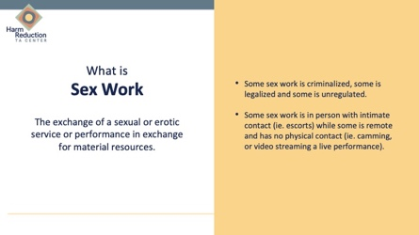 | - Review definition  - Two points on the side note that different forms of sex work have different experiences of criminalization and physical/sexual contact  - Areas were chosen because they are two of the main areas of risk for a persons’ health and wellbeing  - Note that not everyone is going to use the term sex work or sex worker as a term of personal experience and identity.  - When looking for resources, “Sex work” is a term of both domestic and international public health and in sex workers’ speaking on their own rights, and therefore will be the most helpful. | Sex work covers many different experiences and knowing someone does sex work may not tell you much relevant information.
SLIDE 13: WHAT IS SEX WORK?
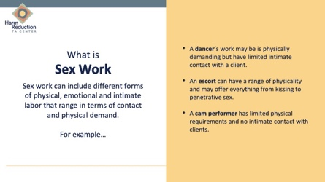 | - Review slide  - Ask how this may impact someone’s risk assessment.  - Name that every person is going to have a different risk assessment for different behaviors. For example, someone with a back injury may have a higher physical risk dancing than escorting. | The risk, and therefore the harm reduction interventions, are not the same for everyone in the sex trade.  If someone is having health issues, they do not have to leave the sex trade to change that risk and moving around in the industry may be a part of harm reduction practices.
SLIDE 14: WHO ARE SEX WORKERS?
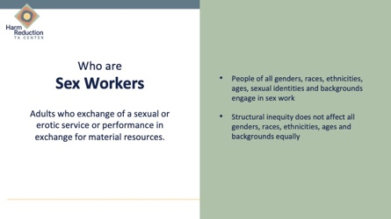 | - Review list and ask audience to add  - Note that we are discussing adults, not because the information does not necessarily apply to young people, but because minors have a different legal status which deserves its own focus and impacts some of the information. | Sex work is a behavior, just like substance use, and there is no single profile of a sex worker.  Impacts of sex work do not affect everyone the same, and marginalized people are more likely to experience the ramifications of sex work than those in a different social position.
SLIDE 15: WHO ARE SEX WORKERS?
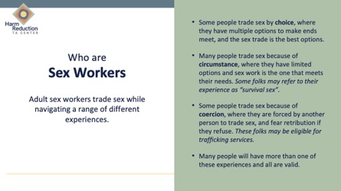 | This slide is the only one which will touch on trafficking, but the information is not exhaustive and if the audience would like more information on trafficking, please see the handout or follow up for additional training.  - Review the first three points, noting that some of those who are engaged by coercion MAY meet the standard to qualify for services earmarked for people experiencing trafficking.  - Choice/circumstance/coercion model comes from anti-trafficking spaces.  - Note: Some audiences may have heard the term “survival sex,” which does not have a consistent, singular definition. Usually, it refers to something where someone is exchanging sex for what we would consider basic resources such as drugs, housing, or food, and meeting that resource need directly would mean they are not going to trade sex. Ask where that would fall in this spectrum.  - Review final point, offer an example, such as: Many people who were working on Backpage were reliant on that site. When the website was seized, many people reported that they were being contacted by people who were offering to find them clients and be their managers, and some people ended up working for someone. Some of those situations ended up being exploitative and coercive. Those sex workers were working probably by circumstance, and when things shifted, they ended up in a coercive situation, and some of those have probably left that situation and returned to working independently.  - Ask what being open to a single person having multiple experiences means for service provision. Suggested answer: It means that we can make space for multiple experiences, and not expect someone to have a single feeling about their sex work. | People may be in many different circumstances and may move between them as their lives change.  If someone has multiple experiences, all are still valid.  Sex workers have a constellation of experience, meaning that they can move between these experiences as their lives change.
SLIDE 16: SERVING SEX WORKERS
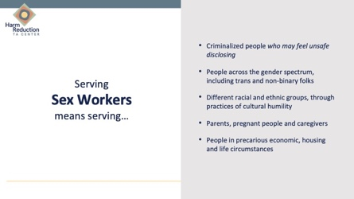 |  | Serving sex workers isn’t a monolithic set of recommendations, but also means being welcome to the experiences sex workers bring. You can’t serve sex workers appropriately if you cannot serve, for example, trans people with cultural humility.
SLIDE 17: BREAK!
 | - Edit slide to let people know when to return
SLIDE 18: TITLE SLIDE, BARRIERS TO CARE
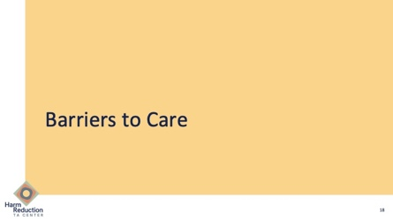

SLIDE 19: VIDEO, SEX WORKERS SPEAK OUT
 | Video Length: 60 seconds  Video Note: When clicking to start the video, the “CC” button will make sure that English subtitles are on. If they are not automatically generated, click on the white box that says “CC” in black letters. | Sex workers face many barriers to care and support.
SLIDE 20: BARRIERS TO CARE
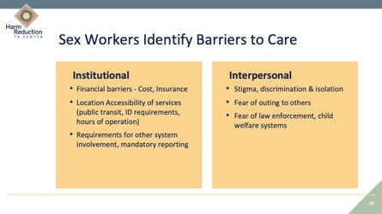 | - Information comes from community responses to some service provision, including in the development of Persist Health Project, a NYC community-based health program  - Describe what institutional barriers are, review list, ask for other ideas; Review the points with examples  - Describe interpersonal barriers with staff, ask for other ideas; Review the points with examples | Many sex workers are seeking care, or would like to get care, but face barriers that can be changed and removed.
SLIDE 21: HOW DO WE DISMANTLE THESE BARRIERS?
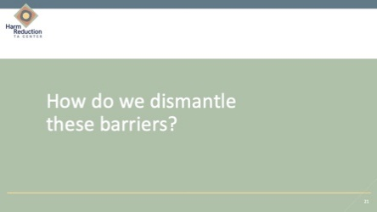
SLIDE 22: DISMANTLING BARRIERS
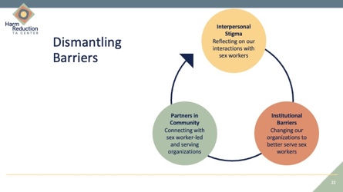 | - Start with the top box (interpersonal barriers) and review all three  - Discuss how these interact with each other as circles of care which reinforce each other
SLIDE 23: INTERPERSONAL BARRIERS
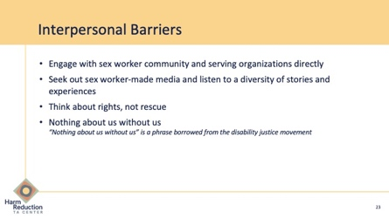 | - Review the list of recommendations  - Ask the audience if they have engaged in any of these practices?  - Ask the audience what the ideas of “rights not rescue” and “nothing about us without us” means to them | Individuals and organizations can take action to reduce barriers for sex workers in their services, and in support beyond their direct work.
SLIDE 24: SEX WORKER HEALTH IN HEALTH DEPARTMENT PROGRAMMING
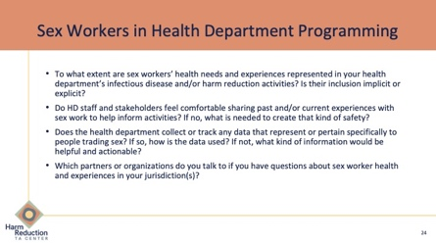 | NOTE: Slide is specific to Health Departments and can be removed for a non-DOH audience.
SLIDE 25: COLLABORATION WITH SEX WORKER-SERVING ORGANIZATIONS
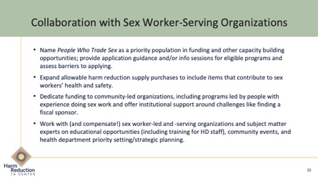 | - Review the list of recommendations  - Ask audience if anyone has engaged in these collaborations, and if they would add anything
SLIDE 26: RESOURCES
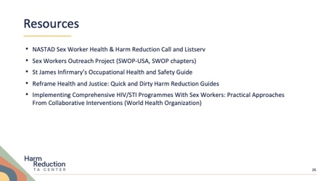 | - Direct audience members to the handout, which has all the resources listed on the slide, as well as additional resources.
SLIDE 27: CLOSING
- Questions listed are meant to offer a reflective moment before leaving the space
- Depending on time and comfort level of the audience, this can be a moment of self-reflection or an ask for a group share.
- General recommendation: offer a moment of self-reflection after the first question, and ask two to three people to share one thing that they learned in the main group, repeat with second question
- Virtual Adjustment: Ask everyone to put their response on a Google doc/Jamboard
SLIDE 28: ENDING SLIDE
 | - Include relevant contact information and how to follow up.

